Lab – Selecting Switching Hardware

1. Objectives

Part 1: Explore Cisco Switch Products

Part 2: Select an Access Layer Switch

Part 3: Select a Distribution/Core Layer Switch

1. Background / Scenario

As a Network Engineer, you are part of a team that selects appropriate devices for your network. You need to consider the network requirements for the company as they migrate to a converged network. This converged network supports voice over IP (VoIP), video streaming, and expansion of the company to support a larger customer base.

For a small- to medium-sized company, Cisco hierarchical network design suggests only using a two-tier LAN design. This design consists of an access layer and a collapsed core/distribution layer. Network switches come in different form factors, and with various features and functions. When selecting a switch, the team must choose between fixed configuration or modular configuration, and stackable or non-stackable switches.

Based on a given set of requirements, you will identify the Cisco switch models and features to support the requirements. The scope of this lab will limit the switch models to campus LAN only.

1. Required Resources

PC with Internet access

1. Explore Cisco Switch Products

In Part 1, you will navigate the Cisco website and explore available switch products.

* 1. Navigate the Cisco website.

At [www.cisco.com](http://www.cisco.com), a list of available products and information about these products is available.

* + 1. From the home page, click **Products & Services** > **Switches**.

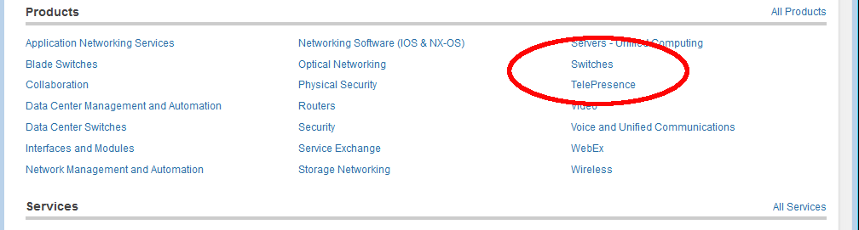

* 1. Explore switch products.

In the Feature Products section, a list of different categories of switches is displayed. In this lab, you will explore the campus LAN switches. You can click different links to gather information about the different switch models. On this page, the information is organized in different ways. You can view all available switches by clicking **View All Switches**. If you click **Compare Series**, the switches are organized by types: modular vs. fixed configuration.

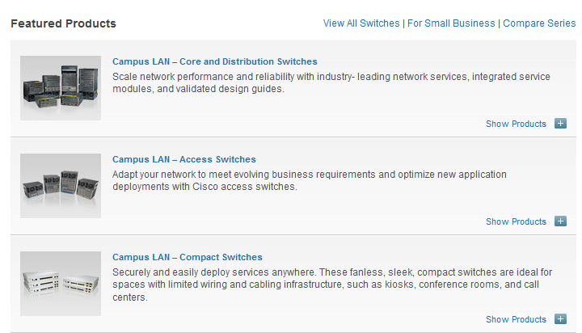

* + 1. Click the heading **Campus LAN – Core and Distribution Switches**.

List a few models and some of features in the table below.

|  |  |  |  |
| --- | --- | --- | --- |
| Model | Uplink Speed | Number of Ports/Speed | Other Features |
|  |  |  |  |
|  |  |  |  |
|  |  |  |  |

* + 1. Click the heading **Campus LAN – Access Switches**.

List a few models and some of features in the table below.

|  |  |  |  |
| --- | --- | --- | --- |
| Model | Uplink Speed | Number of Ports/Speed | Other Features |
|  |  |  |  |
|  |  |  |  |
|  |  |  |  |

* + 1. Click the heading **Campus LAN – Compact Switches**.

List a few models and some of features in the table below.

|  |  |  |  |
| --- | --- | --- | --- |
| Model | Uplink Speed | Number of Ports/Speed | Other Features |
|  |  |  |  |
|  |  |  |  |

1. Select an Access Layer Switch

The main function of an access layer switch is to provide network access to end user devices. This switch connects to the core/distribution layer switches. Access switches are usually located in the intermediate distribution frame (IDF). An IDF is mainly used for managing and interconnecting the telecommunications cables between end user devices and a main distribution frame (MDF). There are typically multiple IDFs with uplinks to a single centralized MDF.

An access switch should have the following capabilities: low cost per switch port, high port density, scalable uplinks to higher layers, and user access functions and resiliency. In Part 2, you will select an access switch based on the requirements set by the company. You have reviewed and become familiar with Cisco switch product line.



**Switch**



**Rest of Company Network**



**LWAPP**

**PC**

**Laptop**

* + 1. Company A requires a replacement access switch in the wiring closet. The company requires the switch to support VoIP and multicast, accommodate future growth of users and increased bandwidth usage. The switch must support a minimum of 35 current users and have a high-speed uplink. List a few of models that meet those requirements.

____________________________________________________________________________________

____________________________________________________________________________________

* + 1. Company B would like to extend services to a conference room on an as-needed basis. The switch will be placed on the conference room table, and switch security is a priority.

____________________________________________________________________________________

____________________________________________________________________________________

1. Select a Distribution/Core Layer Switch

The distribution/core switch is the backbone of the network for the company. A reliable network core is of paramount importance for the function of the company. A network backbone switch provides both adequate capacity for current and future traffic requirements and resilience in the event of failure. They also require high throughput, high availability, and advanced quality of service (QoS). These switches usually reside in the main wiring closet (MDF) along with high speed servers, routers, and the termination point of your ISP.

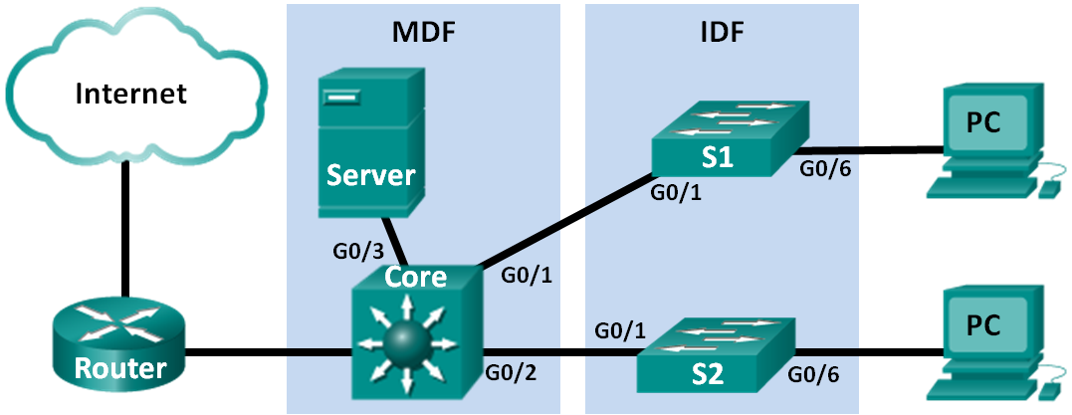

* + 1. Company C will replace a backbone switch in the next budget cycle. The switch must provide redundancy features to minimize possible downtime in the event that an internal component fails. What features can accommodate these requirements for the replacement switch?

____________________________________________________________________________________

____________________________________________________________________________________

* + 1. Which Cisco Catalyst switches would you recommend?

____________________________________________________________________________________

* + 1. As Company C grows, high speed, such as 10 GB Ethernet, up to 8 uplink ports, and a modular configuration for the switch will become necessary. Which switch models would meet the requirement?

____________________________________________________________________________________

1. Reflection

What other factors should be considered during the selection process aside from network requirements and costs?

_______________________________________________________________________________________

_______________________________________________________________________________